**Weekly Report – 4TH week**

Name :- Vaibhav Bhardwaj

Class :- MCA 3rd Semester

Roll No. :- 2222888

GitHub:- https://github.com/R34L-D34TH/college-report

Day 15:-

* MySql Connectivity

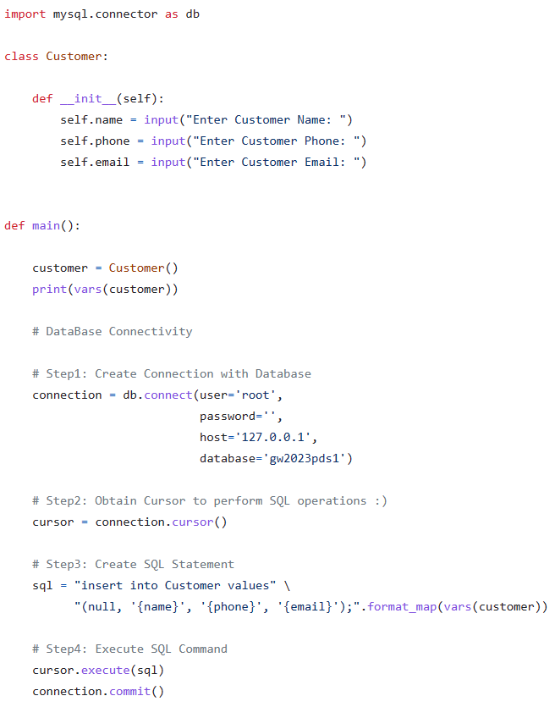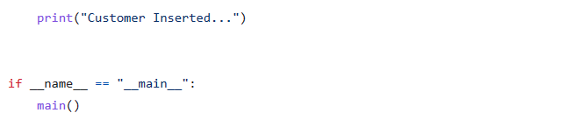Day 16:-

* Project Activity - CRUD operations in Customer with pandas and tabulate

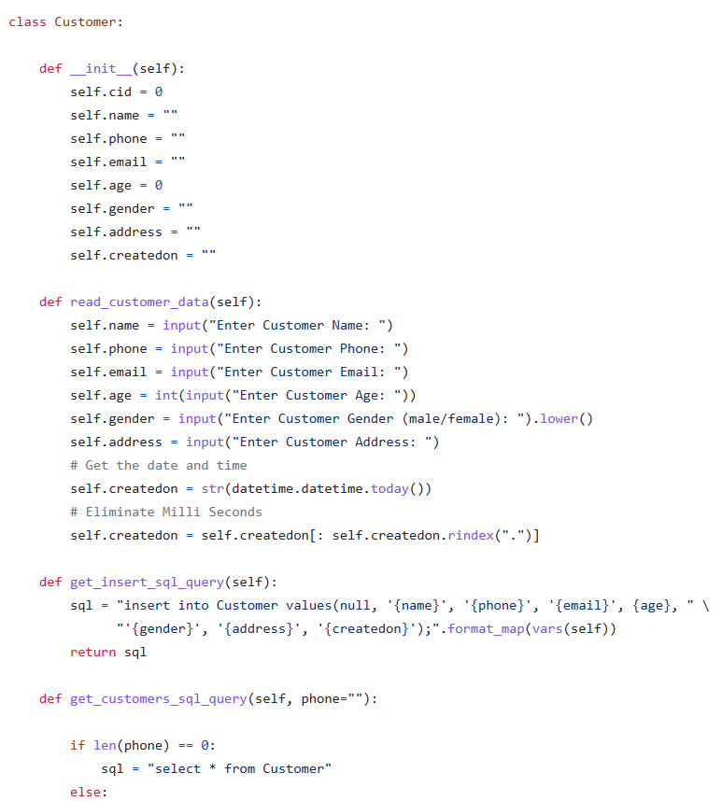

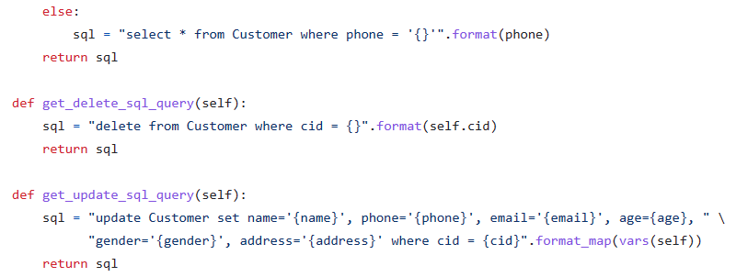

Day 17:-

* Code the Vets App Project to manage pets

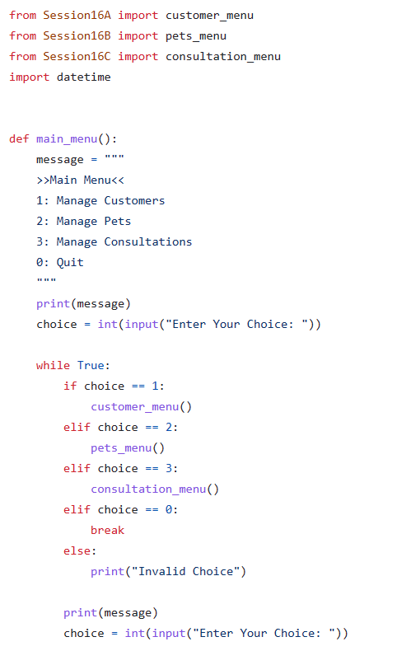

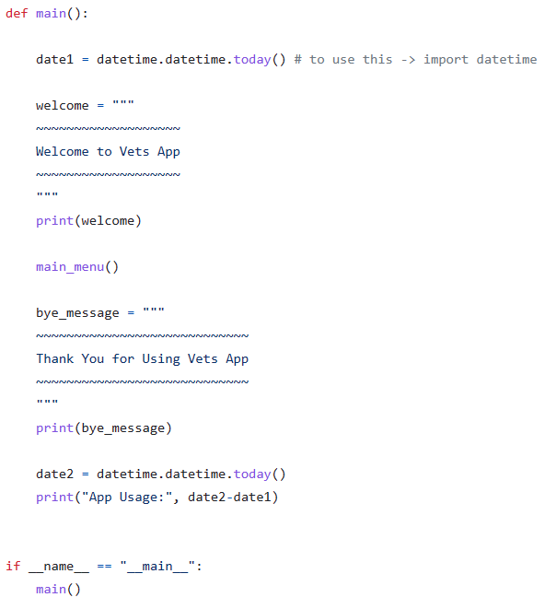

Day 18:-

* Vets App Code the Consultation

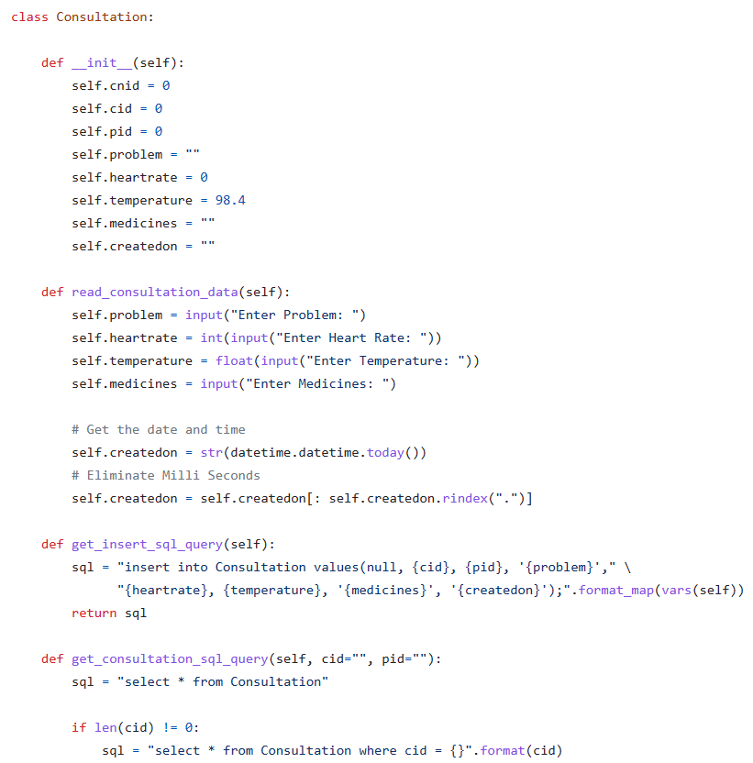

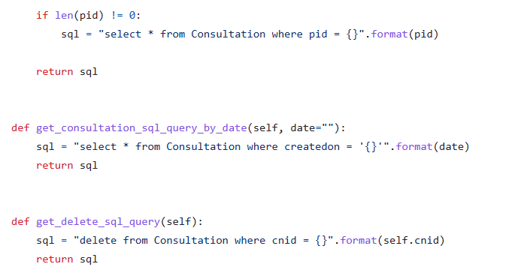

Day 19:-

* Introduction to Raw MongoDB CRUD Operations

